**REGEX**

**.** A single character

**[abc]** Range. ie any one of these characters, can use - like **[A-Z,1-9]**

**[^abc]** Not range. A character that is not one of those enclosed.

**(abc)** Group these characters and remember for later.

**\n** Replace n with a number. Recall the characters matched in that set of brackets. May also be used to rename files or directories.

**|** The logical 'or' operation.

**\** In front of a character, removes it's special meaning.

**REGEX MULTIPLIERS**

**?** The preceding item is optional, it is matched zero or one times.

**\*** The preceding item will be matched zero or more times.

**+** The preceding item will be matched one or more times.

**{n}** The preceding item will be matched exactly n times.

**{n,}** The preceding item will be matched n or more times.

**{n,m}** The preceding item will be matched between n and m times, inclusive.

**REGEX ANCHORS**

**^** From the beginning of the line.

**$** To the end of the line.

**\<** At the beginning of a word.

**\>** At the end of a word.

**\b** Match either the beginning or end of a word.

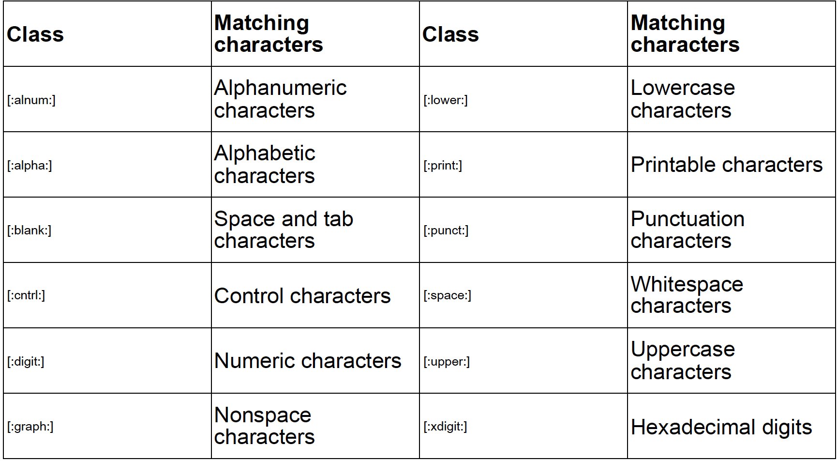

**Examples**

**tolstoy** The seven letters tolstoy, anywhere on a line

**^tolstoy** The seven letters tolstoy, at the beginning of a line

**tolstoy$** The seven letters tolstoy, at the end of a line

**^tolstoy$** A line containing exactly the seven letters tolstoy, and nothing else

**[Tt]olstoy** Either the 7 letters Tolstoy/the 7 letters tolstoy,anywhere on a line

**tol.toy** The three letters tol, any character, and the three letters toy, anywhere on a line

**tol.*toy** The 3 letters tol, any sequence of zero or more characters, and the 3 letters toy, anywhere on a line (e.g., toltoy, tolstoy, tolWHOtoy, and so on)

**egrep '(.)bb\1' myfile.txt**

Find every line with 2 b's and the same character both before and after those b's.

**egrep -l '[0-9]{8,}' /files/projectx/\***

Print each file in the directory projectx which contains a number of 8 digits or more.

**egrep '\b[a-z0-9._%+-]+@[a-z0-9.-]+\.[a-z]{2,4}\b' myfile.txt**

Print every line of myfiles.txt containing an email address.

**^ABC** Match is restricted to beginning of string

**def** Characters 7, 8, and 9, in the middle: abcABCdefDEF

**def$** Match is restricted to end of string

**[[:upper:]]\{3\}** Characters 4, 5, and 6, in the middle: abcABCdefDEF

**[[:upper:]]\{3\}$** Characters 10, 11, and 12, at the end: abcDEFdefDEF

**^[[:alpha:]]\{3\}** Characters 1, 2, and 3, at the beginning: abcABCdefDEF